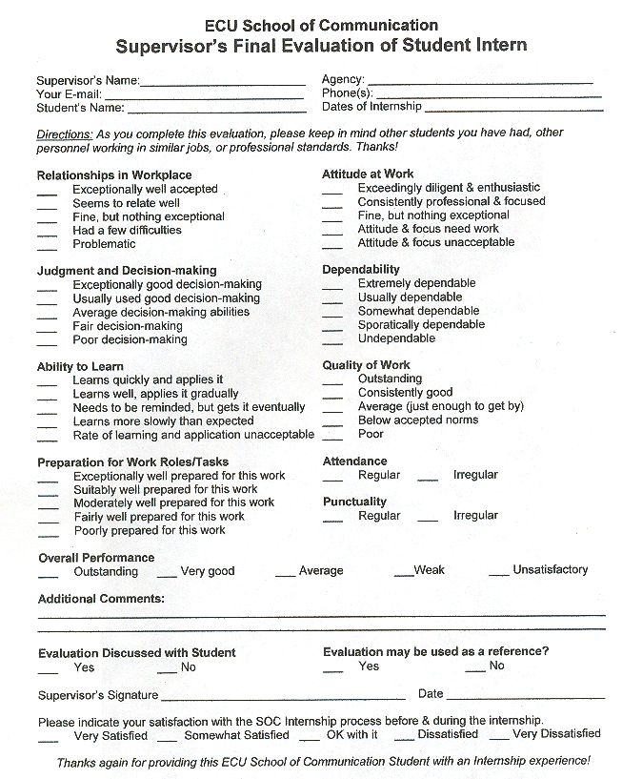
Please submit this form to:
Brittany Thompson Phone: 252-737-4707
Internship Coordinator FAX: 252-328-1509
School of Communication E-mail: thompsonbri14@ecu.edu
101-C Joyner East
East Carolina University
Greenville, NC 27858

